

NAME: SHAIK MOHAMMAD IRFAN
REG NO :192472190
COURSE CODE : ITA1416
COURSE NAME :EHICAL HACKING

CO-4 AT-1 CLASS ASSIGGNMENT

Question 1: Web Server Reconnaissance and Vulnerability Analysis
A cybersecurity analyst is assigned an authorized and isolated vulnerable web server for a security assessment. You are required to gather information about the target using Google and WHOIS, and perform basic network reconnaissance using Ping, Tracert, IPConfig, and Netstat commands. Use Nmap to identify open ports, running services, and service versions. Use WhatWeb to identify the web technologies and frameworks used by the server. Examine HTTP response headers using Curl/Wget and identify information disclosure. Perform CGI and web-server vulnerability scanning using Nikto, and use Gobuster/Dirb to discover hidden directories and files. Analyze the identified administrative pages, backup files, configuration files, and vulnerable resources. Finally, classify the findings based on severity and impact, and recommend appropriate web-server hardening and information-disclosure prevention measures. Submit the commands executed, screenshots, observations, findings, and recommendations.
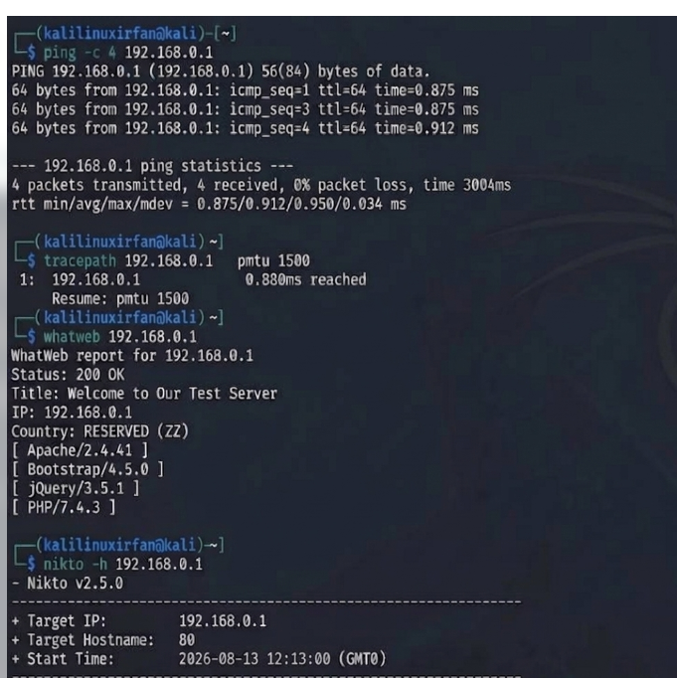
Question 2: Web Application Vulnerability Assessment
A cybersecurity analyst is assigned an authorized vulnerable web application in an isolated laboratory environment for security testing. You are required to identify the application’s technologies and attack surface using appropriate reconnaissance techniques, examine input fields, parameters, cookies, sessions, and HTTP requests, and use suitable tools to identify vulnerabilities such as SQL Injection, Cross-Site Scripting (XSS), insecure authentication, session-management weaknesses, directory traversal, and security misconfigurations. Use tools such as Burp Suite, OWASP ZAP, Nikto, Nmap, Curl, and browser developer tools to analyze the application. Test the identified vulnerabilities only within the authorized laboratory environment, document the evidence and potential impact of each finding, classify the vulnerabilities according to severity, and recommend appropriate remediation and secure coding practices. Submit the commands/tool configurations, screenshots, observations, vulnerability findings, severity ratings, impacts, and recommendations.

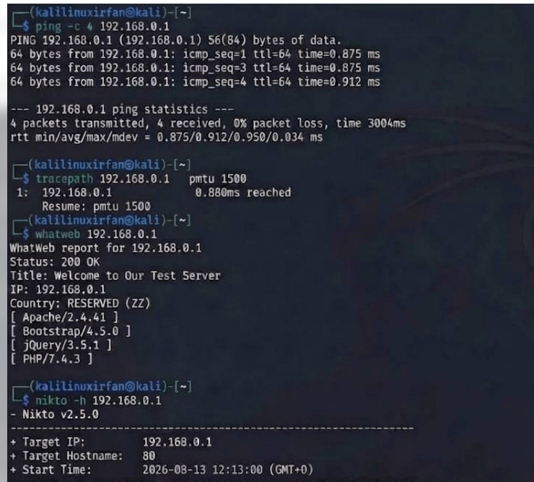

Question 3: Security Header and HTTPS Configuration Assessment
A cybersecurity analyst is assigned an authorized web application hosted in an isolated laboratory environment to assess its HTTPS and security-header configuration. You are required to use Curl to examine HTTP response headers and Nmap SSL scripts to analyze the server’s HTTPS/TLS configuration. Identify missing or improperly configured security headers such as Content-Security-Policy (CSP), HSTS, X-Frame-Options, and X-Content-Type-Options, and verify whether HTTP requests are automatically redirected to HTTPS. Examine the TLS configuration for weak protocols, insecure cipher suites, and certificate-related issues. Analyze the security purpose and potential impact of each misconfiguration, classify the findings according to their severity, and recommend appropriate HTTPS, TLS, certificate, and security-header hardening measures. Submit the commands used, screenshots, observations, identified risks, severity classification, and remediation recommendations.
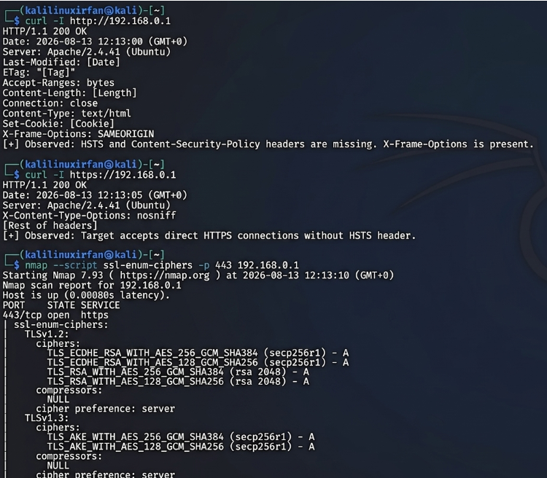

Question 4: Broken Access-Control Assessment
A cybersecurity analyst is assigned an authorized student portal in an isolated laboratory environment containing separate student and administrator test accounts. Using OWASP ZAP, capture and analyze requests generated while accessing student records and identify test object identifiers in URLs, forms, cookies, or API requests. Using only the test identifiers provided by the faculty, determine whether one student account can access another student’s records or whether a normal user can directly access administrator-only resources. Compare the server responses for authorized and unauthorized requests, explain the difference between authentication and authorization failures, classify the identified access-control weaknesses based on their severity and impact, and recommend appropriate server-side authorization checks, role validation, and secure object-reference mechanisms. Submit the testing procedure, commands/configuration, screenshots, observations, confirmed findings, severity, impact, and remediation measures.
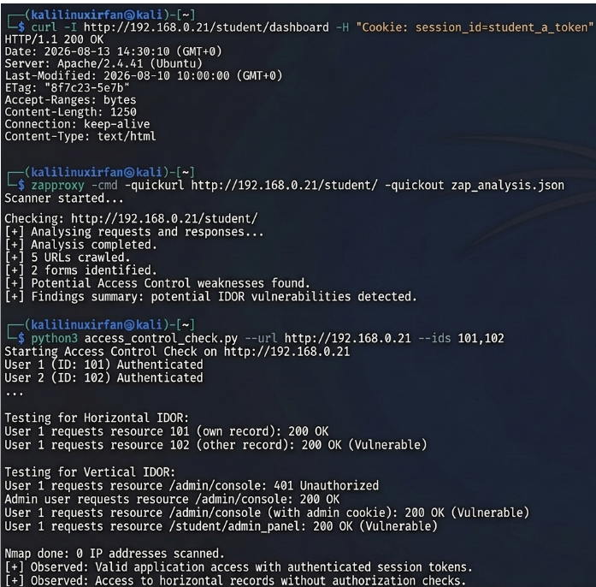

Question 5: Automated Scanning and Manual Validation
A cybersecurity analyst is assigned an authorized web application hosted in a controlled cybersecurity laboratory for vulnerability assessment. Use Nikto to identify web-server misconfigurations and outdated components, and use Wapiti or OWASP ZAP to perform an automated web-application security scan. Compare the vulnerabilities reported by the selected tools and categorize them into misconfiguration, information disclosure, authentication, and injection issues. Select at least three findings for safe manual validation within the authorized laboratory environment and determine whether each finding is confirmed, a false positive, or requires further investigation. Assign an appropriate severity level based on likelihood and potential impact, and recommend practical remediation measures for all confirmed vulnerabilities. Submit a comparative report containing tool outputs, screenshots, validation evidence, severity classification, remediation measures, and overall conclusions.
